Corrective Action and Preventive Action (CAPA) Policy

Table of Contents
- Introduction 2
- Definitions/Acronyms 2
- References/Associated Documents 3
- Responsibilities 4
- Procedure 5
- Process Flow Chart 11
- Summary of Changes 12

- Introduction
The corrective and preventive action process is intended to prompt analysis of appropriate sources of quality information to rectify identified or potential causes of non-conforming product, processes or other quality issues including customer complaints and audit observations. This system also helps support continual quality improvement within the company’s Quality Management System.
  - Purpose - This document defines LGC Bio search Technologies’ policy regarding the identification of quality issues, correction of the issue as well as the corrective and/or preventive action necessary to avoid recurrence. CAPA requires manager and employee support to make the system work.
  - Scope - This document pertains to LGC Bio search Technologies’ products, procedures, processes, materials, and/or services. It is intended to comply with domestic and international requirements relating to corrective and preventive actions.
- Definitions/Acronyms
  - CAPA Originator - A member of the Quality Assurance department in charge of opening a CAPA record and ensuring that it complies with the requirements of this SOP.
  - CAPA Action Plan - A list of corrections and corrective and preventive actions to address existing or potential nonconformities. For continuous opportunity CAPAs, the CAPA plan is the list of actions needed to improve the product/process.
  - Capa Category - A severity level assigned to a CAPA. The CAPA categories are Observation, Recommendation, Critical, Major, and Minor.
  - Correction - Action taken to correct an observed non-conformity.
NOTE: Correction may take place within the associated Nonconformance Report.
  - Corrective Action - Action taken to eliminate the root cause of an existing nonconformity, defect, or other undesirable situation to prevent recurrence.
  - Critical - A category assigned to a CAPA when the finding has a very high potential of affecting process and/or product Quality, is a direct violation of compliance with regulatory requirements and standards and there exists an insurmountable amount of evidence of noncompliance.
  - Customer Complaint - Any customer complaint, customer notification, or product recall that is documented in our customer service incident (CSI) database.
  - DNR - Deviation and Nonconformance Report: A quality system record that documents the occurrence and root cause of materials which fail to conform to specified requirements.
  - Effectiveness Verification - A documented review to verify that the actions taken to address the non-conformity were effective in correcting and preventing recurrence.
  - Investigation - A process for determining the root cause of a nonconformance or other issue. An investigation may include involvement and/or notification of external parties outside the organization.
  - Major - A category assigned to a CAPA when the finding has a potential of affecting process and/or product quality and may be a violation of compliance with regulatory requirements and standards.
  - Management Representative - A member of management who, irrespective of other responsibilities, has established authority and responsibility for ensuring that the Quality System and regulatory requirements are effectively established and effectively maintained and reporting on the performance of the quality system to management for executive responsibility and review.
  - Minor - A category assigned to a CAPA when the finding may not directly affect process and/or product quality but is likely to be a Quality System related issue.
  - Preventive Action - Action taken to eliminate the potential for nonconformance, defect, or another undesirable situation to prevent occurrence.
  - Root Cause - The underlying cause of a nonconformance or other issue that, when corrected, will prevent recurrence. Root cause may be determined by using a variety of tools including 5 Whys, 6M, Fishbone Analysis or others to deduce the actual cause of the issue.
  - OFI (Opportunity for Improvement) - Action to address an opportunity identified to improve a process, product or procedure.
- References/Associated Documents
  - 21 CFR Part 820, Medical Device; Current Good Manufacturing Practice (cGMP) Final Rule; Quality System Regulation, Food and Drug Administration, Federal Register.
  - ISO 9001, Quality management systems – Requirements, International Organization for Standardization.
  - ISO 13485, Medical Devices – Quality Management Systems – Requirements for Regulatory Purposes, International Organization for Standardization.
  - ISO 14971, Medical Devices – Application of Risk Management to Medical Devices, International Organization for Standardization.
  - ICH Q7 Good Manufacturing Practice Guidance for Active Pharmaceutical Ingredients, Guidance for Industry
  - ICH Q9 Quality Risk Management
  - ICH Q10 Pharmaceutical Quality System
  - QM-203151 Quality Manual
  - SOP-200524 Internal Quality Audits
  - SOP-202004 Document and Change Control Policy
  - SOP 202192 Policy for Control of Nonconforming Product
  - SOP-202278 Management Review Procedure
  - SOP-203397 Record Retention Policy
  - SOP-203780 Risk Assessment and Evaluation Procedure
  - WI-203961 Instructions for Use of the FileMaker Pro CAPA System
  - SOP-203727 Complaint Handling Policy
  - SOP-202192 Policy for Control of Nonconforming Product
  - FM-201900.02 CAPA Extension Request Form
  - SOP-209756, Investigation Guidelines
  - SOP-210071 Change Management Procedure
- Responsibilities
  - LGC Bio search Technologies employees are responsible for identifying and communicating the need for corrective and preventive actions which may become evident within their job functions and responsibilities.
  - Senior Management supports the CAPA Program by holding CAPA assignees accountable for completing assigned CAPA actions in an effective and timely manner. The timeliness of CAPA is discussed as an agenda item during Management Review. Trend analysis of CAPA is discussed as an agenda item during Management Review. Open CAPA are also reviewed during Management Review.
  - Employees assigned CAPAs are responsible for all stages of the process. Should a CAPA assignee feel that the task would benefit from a team approach, he/she may convene a team and delegate responsibilities among the members. The assignee, however, retains ultimate ownership of the CAPA. Effective and timely management of CAPA assignments may be a performance item to be considered during annual employee review.
  - Area Management is responsible for ensuring the implementation of CAPA actions and providing QA with documented evidence for implementation of all actions QA is responsible unless otherwise designated for verification of effectiveness of CAPA as well as including documented evidence of effectiveness in the CAPA file.
  - The Management Representative ensures the suitability and effectiveness of the Company’s CAPA program and is responsible for reporting on CAPA data and program issues and trends at Management Reviews.
  - Additionally, the Management Representative or Designate convenes the regular CAPA Review meetings.
  - Quality Assurance administers CAPA activities. Quality Assurance is also responsible for actively monitoring and tracking CAPA status, providing CAPA procedure guidance and consultation, and for reviewing implemented corrective and/or preventive actions for completeness and effectiveness. Quality Assurance maintains and updates the OFI database and ensures OFIs are being completed in a timely manner.
- CAPA Initiation
  - Issues resulting from data sources are reviewed on an ongoing basis through Management Review to determine the need to be rolled into the CAPA system or tracked in the OFI database.
  - Based on a risk assessment, Quality Assurance will determine if a CAPA or OFI will be opened. All external findings shall be tracked in the CAPA system.
  - Data Sources
    - Potential CAPA Sources
      - CAPA shall be issued for all regulatory body findings unless otherwise justified in the audit response.
      - CAPA shall be issued for Major Internal Audit and vendor findings unless otherwise justified in the audit response and may be issued for Minor and Observation findings.
      - CAPA shall be issued for all GMP and Hybrid confirmed complaints unless otherwise justified in the complaint record.
      - CAPA may be issued for trend findings as justified in the trend documentation.
      - CAPA shall be issued for deviation or nonconformance as needed based on DNR impact assessment form FM-202188.02 and risk assessment.
      - CAPA may be issued for a management review action item.
    - Potential OFI Sources
      - OFI may be issued for low-risk action items resulting from Management Review or other quality system reviews or trend analyses.
      - OFI may be issued for continuous improvement initiatives.
      - OFI may be issued for procedural updates.
      - OFI will be issued for internal audit recommendations.
- CAPA Procedure
  - Identification and tracking of CAPAs within the LGC Bio search Technologies Quality System is managed by Quality Assurance through the FileMaker Pro CAPA module in the system. CAPAs and their status are also presented at Management Review meetings and discussed.
  - The source of the CAPA issue, such as internal or customer audit findings, is identified within the database, and all steps in the workflow of CAPA management are captured in a timely manner.
  - All CAPA activities including such elements as assignment of responsibility for key activities, and due dates for completion must be documented as part of the CAPA management process. All this data is considered part of the Quality Record.
    - At a minimum, the following steps shall be included as part of the CAPA process:
      - Investigating and determining the root cause(s) of nonconformities.
      - Assigning the level of risk to the CAPA
      - Evaluating suitable action to ensure that nonconformities do not recur.
      - Determining and implementing the action(s) needed.
      - Recording the results of the actions taken.
      - Reviewing the effectiveness of the corrective action taken
      - Reviewing the effectiveness of the preventive action taken.
    - How to assign risk level to the CAPA
      - Determine the “Total Risk Score” by assigning a “Frequency” and a “Severity” Score to the finding
      - Assigning Frequency for Nonconformity
1 | Nonconformity is not likely to recur or will only occur under exceptional circumstances (Rare; 0.01%)
2 | Nonconformity could possibly occur at some time in the future if not addressed (Unlikely; 0.1%)
3 | Nonconformity expects to recur sporadically or intermittently if not addressed (Possible; 1%)
4 | Nonconformity expects to recur several times if not addressed (Likely; 10%)
5 | Nonconformity will happen frequently if not addressed (Almost Certain; 100%)
      - Assigning Severity of a Nonconformity
1 | Nonconformity has no perceptible impact on final product quality, patient safety, data integrity or compliance/adherence to company processes
2 | Nonconformity has potential for a negative impact on final product quality, patient safety, data integrity or compliance/adherence to company processes
3 | Nonconformity has negative impact on final product quality, patient safety, data integrity or compliance/adherence to company processes
4 | Nonconformity has a critical impact on final product quality, patient safety, data integrity or compliance/adherence to company processes
5 | Nonconformity has a catastrophic impact on final product quality, patient safety, data integrity or compliance/adherence to company processes (e.g. nonconformity impacts the customer’s regulatory filings)
      - Risk Matrix
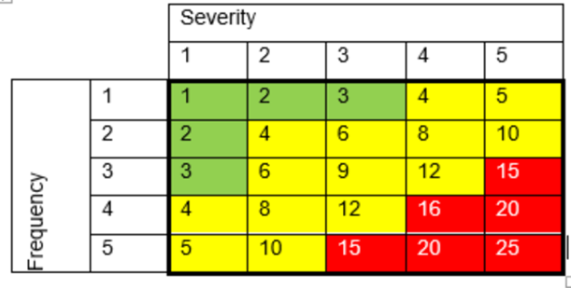
        - The colored cells within the matrix represent the Total Risk score or the Frequency Score multiplied by the Severity Score.
      - Based on the risk score, the following recommended timeframes to complete the Root Cause Investigation and Action Plan of the findings are as follows:
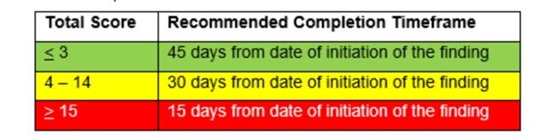
 | In FileMaker Pro, the completion date of the Root Cause Investigation and Action Plan is captured as the recipient Signature and Date on the CAPA Action Plan tab. See section 4.5.8

  - CAPA files are confidential and proprietary to LGC Bio search Technologies. CAPAs opened because of a customer audit finding may be viewed only by the customer whose audit resulted in the CAPA. CAPAs that result from other sources, including but not limited to regulatory audit findings, customer complaints, deviations and nonconformances, and Management Review items may not be viewed by our customers.
  - Quality Assurance shall open and track CAPAs through to closure.
  - Assignment of CAPAs
    - Any CAPAs open will be assigned to employees at the Supervisor/Manager level or any other trained SMEs or Quality Personnel. QA must be looped into discussion before the CAPA is opened to ensure they are included in the decision to open the CAPA. There must be a discussion with the proposed CAPA owner before the CAPA is assigned to them just to ensure they are in alignment with the problem statement and proposed due date.
      - The CAPA owner may delegate tasks to other employees (e.g. revising a document, performing analysis on test results, etc.), but the CAPA owner maintains responsibility for documentation of actions taken to resolve the CAOA and is ultimately responsible for the closure of the CAPA by the target completion date.
      - Note: An individual should not be assigned a CAPA until he/she has completed training at this SOP.
    - The CAPA assignee shall take into consideration tangential effects any planned changes may produce.
    - Effecting the changes will most likely involve the Document and Change Control Policy, the work instruction and form of which (WI202004.01 and FM-202004.02) list some of the elements that need to be considered.
    - The site must be identified when opening the CAPA and the following are the unique identifiers for each site that should be included as a prefix in the CAPA title:
      - PET: Petaluma, NOV: Novato, PETGMP: For Petaluma GMP related CAPAs, PETNOVHYB: For CAPAs related to the PET NOV hybrid workflow, THE: Therapeutics, STN: Steinach
      - Example of CAPA title for Novato: NOV: The process for Internal Audits is not effective
      - Note: NOV, PETGMP, and PETNOVHYB CAPAs will all be tracked via Novato CAPA Review Board
  - CAPA Closure
    - Final review and closure of corrective and/or preventive action(s) within the LGC Bio search Technologies Quality System is monitored by Quality Assurance. Closure of a CAPA is the completion of all required actions by the CAPA owner and verification of those actions by QA. CAPA closure occurs prior to verification of CAPA effectiveness at the verified completed stage in FileMaker Pro systems.
    - The progress of CAPAs is actively monitored by QA personnel to ensure corrective actions are taken towards closure without undue delay.
    - Special consideration regarding timelines will be given for complex CAPAs. In the event a longer timeframe is required, the rationale for the extended timeframe shall be documented in the CAPA.
    - Long-term implementation or verification may be handled as projects tracked outside of the CAPA program as documented and justified in the CAPA program.
      - If implementation activities as part of a CAPA are being handled via the change management procedure, the change management form number assigned to that change can be referenced in the CAPA record as justification to close out the CAPA. Reference SOP-210071 Change Management Procedure for more details.
      - Internal audits may be used as one method to verify that long-term activities are proceeding as required.
      - Long-term monitoring should be addressed as part of Management Review activities.
    - Note: To avoid potential conflict of interest the QA personnel verifying the completion and effectiveness must be independent from the CAPA initiator and owner whenever possible.
  - Verification of CAPA Effectiveness
    - Verification of CAPA effectiveness is documented in the CAPA system. Action plans for CAPA are not to be approved unless plans for verification of effectiveness are stated in the Action Plan section. If the effectiveness verification determines that the CAPA actions were not satisfactorily addressed after closure, the CAPA will be reopened by QA or another CAPA will be opened which will be documented in the CAPA.
    - QA will manage and track CAPAs all the way through effectiveness through CAPA Review Board from initiation to verification of completion of actions and verification of effectiveness of actions to complete the CAPA. CAPA owners with QA oversight will identify the plan to monitor effectiveness before the action is completed and this is documented in the CAPA action plan. Once QA verifies completion of all actions within the CAPA, QA will schedule the verification of effectiveness in the CAPA record at a maximum of 6 months after implementation of the last action and monitor to completion through CAPA Review Board. The CAPA due date may be extended by QA to account for the verification of effectiveness. This extension shall be recorded in the CAPA record. The CAPA owner may also be updated to a QA representative during the verification phase to ensure FileMaker notifications are sent to the appropriate personnel.
    - Objective evidence of effectiveness will be added to the CAPA record as applicable.
    - The status of open and non-verified CAPAs is reviewed during Management Review and CAPA Review Board. Closed CAPAs and the effectiveness of the actions taken are discussed during the Management Review until the effectiveness is considered verified.
    - Internal audits may also be used to monitor CAPA progress and provide an opportunity to review and document CAPA effectiveness.
    - A CAPA is truly considered completed once the Verification of effectiveness has been verified by QA in the FileMaker Pro. This is the true end of the CAPA lifecycle.
  - Communication of CAPA Data
    - As part of the CAPA workflow, departments that may be impacted by the issue may be requested to participate in a CAPA Team or Investigation or may be notified as part of CAPA implementation.
    - CAPA status meetings may be held, as planned in the CAPA, to ensure that progress is made toward the timely completion of CAPAs. Meetings will include any employee who is a CAPA assignee for a CAPA that is open if deemed necessary. If held, status updates will be prepared as a record of the CAPA status meeting which will be maintained in the CAPA file.
    - CAPA progress will be tracked through CAPA Review Board, and all impacted departments will be extended an invite to the CAPA Review Board
  - Notification Process for CAPA
    - Notifications shall be sent out by e-mail to CAPA assignees and Quality Assurance on the following schedule:
      - After the “Completed by” field has been filled in electronically, the system will send notification to Quality Assurance to verify completion of the CAPA actions
      - 60 days prior to the target completion date.
      - 30 days prior to the target completion date.
      - 15 days prior to the target completion date.
      - 7 days prior to the target completion date.
      - Every 7 days following the target completion date for any overdue CAPA.
      - When a CAPA is reopened
    - Any aging CAPAs shall undergo the following additional notification requirements for the purpose of escalation:
      - Aging Reports may be generated and sent to Management.
      - Aging CAPAs will be discussed during CAPA review boards and tracked to completion
  - Assessment of Risk-
    - Any CAPAs opened shall be used to reassess process risks according to the procedure defined in SOP-203780 Risk Assessment and Evaluation Procedure. Risk documentation will be updated as needed after implementation of CAPA actions.
    - Any CAPAs opened in relation to Therapeutics products or processes shall be used to reassess process risks according to the procedure defined in SOP- 208833 PSOP043 Risk Management.
  - Requesting a Due Date Extension
    - It is a requirement that all CAPA be addressed and closed without undue delay.
    - If a due date extension is required, the CAPA owner is responsible for filling out all sections of FM-201900.02.
    - This form will require signatures from the CAPA owner, their manager, and approval and signature from QA. It is the CAPA owner’s responsibility to route this form through the approval process.
    - Completed forms shall be submitted to the site QA Inbox to be included in the CAPA record.
  - Monitoring CAPAs and Ensuring Timeliness
    - CAPA Review Boards will be held at a minimum frequency once per month to track open CAPAs and ensure timeliness. Meetings can be held virtually or in person as needed.
    - CAPA Review Board Meeting Minutes will be held at each meeting and filed according to SOP-203397 Record Retention Policy. Meeting minutes should include:
      - Date of Meeting
      - Name of individual preparing the meeting minutes
      - List of Expected and Actual Attendees
      - Agenda of meeting
      - List of CAPAs covered in the meeting with due dates
      - Information regarding whether extensions are required and rationale for extension with proposed new due date
      - Progress updates for CAPAs

Process Flow Chart

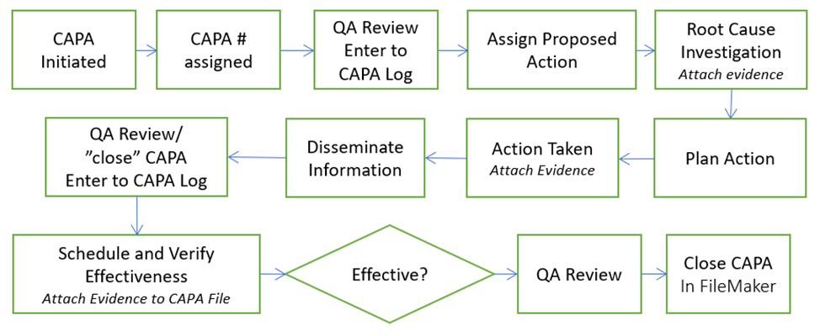
**Risk Assessment is conducted when CAPA is initiated. See SOP-203780 Risk Assessment and Evaluation Procedure. Risk Assessment is calculated with a risk score with an assigned “Frequency” and “Severity” Score. (Refer to section 5.4.2 for more details on determining Risk Scores and setting CAPA timelines based on level of risk)
- OFI Procedure
  - OFIs will be entered into the OFI Database and be shared via Microsoft Teams (or equivalent sharing software).
  - OFIs will be assigned an owner based on applicable process or department and a due date based on risk assessment and available resources.
  - The database will include a unique identification number for each OFI and track the site, data source, description, owner, and due date.
  - Quality Assurance will ensure the database is updated and items are being completed in a timely manner.
  - Quality Assurance will use their discretion to assemble appropriate personnel to review the OFI database as necessary.
  - OFI status may be included in the annual Management Review and/or site review boards.

- Summary of Changes

Revision | Description of Change | CRR No.
19.0 | Added section 5.15 for CAPA Review Boards for monitoring and note to process flow chart about when to conduct risk assessment and instructions how to conduct risk assessment. Added reference to SOP-203397 Records Retention Policy, Added requirement for verifying effectiveness within 6 months of implementation of last action, Added requirements for adding site impacted as a prefix within the title, Added to section 5.8.1 that QA must be looped into decisions to open a CAPA and that individuals must be trained to this SOP before being assigned ownership of a CAPA. | 2020-0316
20.0 | Added verbiage that SMEs and Quality personnel can also be assigned CAPAs, added more clarity around effectiveness verification to align with updates in FMP. Revised CAPA notification section to align with FMP functionality | 2020-0837
21.0 | Added 5.9.5 to state: Note: To avoid potential conflict of interest the QA personnel completing the verification of completion and verification of effectiveness must be independent from the CAPA initiator and owner. Updated section 5.10.1 to state, “Action plans for CAPA are not to be approved unless plans for verification of effectiveness is stated in the Action Plan section.” | 2020-0976
22.0 | Update CAPA Categories in section two Added reference to Hybrid Workflow  Update the “Closed by” language to Actions completed by  Updated risk assessment section to apply to all CAPAs and not only GMPCS | 2021-0556
23.0 | Added a section for OFIs and how they are handled and initiated. Added SOP-210071 Change Management Procedure to references and a statement around when CAPAs can be closed out when the actions are being handled via change management. | 2021-1500
24.0 | Updated verification of effectiveness details in section 6.8.2. | 2022-0099

